[Coherent Inc.](http://www.coherent.com/index.cfm)

**MONACO Interface Summary**

**Revision 0.13**

Authors: Frank Canova & Greg Dumond & Jennifer Charrier & Xuren Huang

**CONTENTS**

1.0 PURPOSE 2

2.0 MONACO CONNECTORS 2

2.1 SYNC 1 and SYNC 2 2

2.2 GATE1 and GATE2 3

2.3 EXT MOD 3

2.4 USB 4

2.5 ETHERNET 4

2.6 RS232 4

2.7 CHILLER RS232 5

2.8 INTERLOCK 5

2.9 EXTENDED INTERFACE 5

2.10 POWER UMBILICAL 7

3.0 BEAM MODULATION MODES 8

4.0 POWER SUPPLY 9

4.1 Lambda converter 10

4.2 Power conditioning 10

5.0 BASIC COMMANDS FOR OPERATION 11

5.1 Interlock Faults and warnings 13

5.2 Example command sequence 13

5.2.1 Startup – Regular operation 13

5.2.2 Monitoring while operating 14

5.2.3 After process is complete – Check hours and spot condition 14

5.2.4 Shutdown 14

6.0 Document change log 16

# PURPOSE

This document describes the MONACO electrical interface and also contains a quickstart for the commands to control the laser. It is intended to give customers advance information prior to complete documentation. MONACO is still being refined prior to production and any information in this document is subject to change. Please refer to upcoming final customer documentation for a complete description of the interface.

**Important note: It is the customer’s responsibility to comply with IEC60825 safety standards when there is any use of the signals supplied in this document.**

# MONACO CONNECTORS

There are 12 electrical connectors in the back of MONACO for connecting to equipment. This diagram shows the placement of the connectors at the rear of the head:

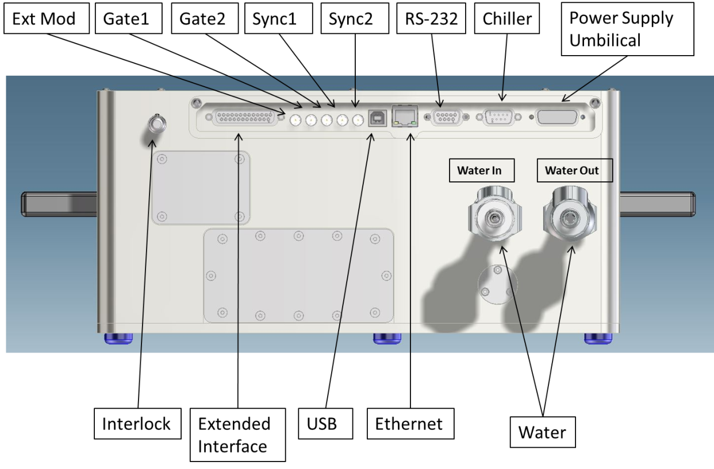

*(Diagram shown for placement only. May not be mechanically accurate)*

## SYNC 1 and SYNC 2

* Purpose: Output signal fixed delay from laser pulse and 50nS wide. Intended to be synchronous with the output laser pulses. Sync 1 follows the Internal rep rate as shown on the Triggering tab of the GUI. Sync 2 follows the output pulse, including any Division, Burst or Gated action selected by the user .
* Connector: HD-BNC Amphenol 034-1030.

Mating connector: Amphenol 034-5017.

HD-BNC to BNC adaptor: APH-BNCJ-HDBNCP

HD-BNC to BNC cable 12”: Amphenol 095-666-44815

* Signal levels/Impedance. Source is four parallel 74ACT541 drivers at 5V. Designed to drive a 50 Ohm line.

## GATE1 and GATE2

Purpose: Input to control pulsing. Gate1 is used to control the duration of a string of pulses. That is if the Pulse Mode is set to 1, laser pulses will be produced as long as the Gate1 signal is high. Gate 2 is a spare for future use. It is connected to internal timing circuits but it has no function at present. Gate 1 also has a function in pulse mode 3. This is called Divided Gate mode. That is a pulse rate is produced that is the fixed pulse rate of approximately 1MHz divided by an integer. So if RRD=2 were sent the rate would be 500kHz, 3 gives 333kHz, 4 gives 250kHz etc. If PM=3 then when the Gate1is high you will get laser pulses at a reduced rate for as long as Gate1 is high.

* Connector: HD-BNC Amphenol 034-1030.

Mating connector: Amphenol 034-5017.

HD-BNC to BNC adaptor: APH-BNCJ-HDBNCP

HD-BNC to BNC cable 12”: Amphenol 095-666-44815

* Signal levels/Impedance: 3.3V to 5V high, 0 to 0.5V low input. 100 ohm series resistor. 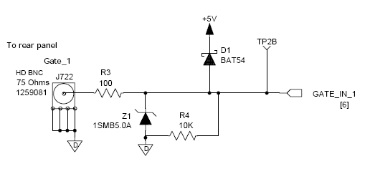

## EXT MOD

* Purpose: Input to modulate output beam when in the external modulation mode (EM=1). See section 3.0 below for details on how to set the mode to use this signal.
* Connector: HD-BNC Amphenol 034-1030.

Mating connector: Amphenol 034-5017.

HD-BNC to BNC adaptor: APH-BNCJ-HDBNCP

HD-BNC to BNC cable 12”: Amphenol 095-666-44815

* Signal levels/Impedance: zero to 5V waveform. 100 ohm series resistor. The fastest modulation you can hope to achieve is about 200kHz square wave.

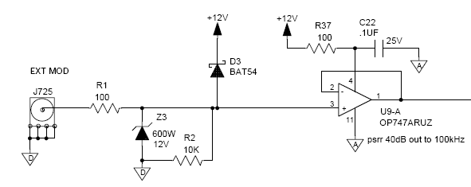

## USB

The USB connector uses the industry standard type B receptacle. Industry standard USB signal levels and Microsoft’s RNDIS protocol is used. It can be connected to a standard USB connector on a PC to control the laser from (for example) Coherent’s supplied GUI.

## ETHERNET

The Ethernet connector uses the industry standard receptical for an RJ45 connector (sometimes called an 8P8C connector). It can be connected to a switch, router or PC using Cat5 cable. A PC connection would require a cross-over cable wiring. Once the IP address of the laser is known, a Telnet session can be established to MONACO and the same commands can control the laser just like the RS232 or USB connections.

## RS232

The customer RS232 connection is a standard female 9-pin D-sub (DE-9) connector. A cable with a male connector is needed to use this interface. The following pins must be connected. Only 19200 Baud is supported.

|  |  |  |
| --- | --- | --- |
| Pin | Signal name | Notes |
| 3 | TxD | Transmit data (RX into laser) |
| 2 | RxD | Receive data (TX from laser) |
| 5 | GND | Common ground. |
| 1,4,6,7,8,9 |  | No connection |

## CHILLER RS232

Coherent supplies a custom cable to connect between the chiller and Monaco head. Although some RS232 signals are used, most signals are non-standard and only compatible with the P1130 and P1430 chillers. The connector on the laser is a female 9-pin D-Sub. Do not plug this connector into any other equipment. **Note:** The following pinout applies to headboard revision AC.

|  |  |  |
| --- | --- | --- |
| Pin | Signal name | Notes |
| 1 | GND | Common ground |
| 2 | RxD | Receive data (RX into laser) |
| 3 | TxD | Transmit data (TX from laser) |
| 4 | CHILL_FLOW |  |
| 5 | GND | Shield |
| 6 | CHILL_LEVEL |  |
| 7 | CHILL_TEMP |  |
| 8 | CHILL_REM_ST- |  |
| 9 | CHILL_REM_ST+ |  |

## INTERLOCK

The interlock connector is connected to customer equipment for safety, such as switches on access doors. As long as the interlock connection is made, the laser will operate. A 12mA current loop supplies power to this connection. A 3-pin ITT connector is used on the Monaco head with the following connections. **Note:** The following pinout applies to headboard revision AC.

|  |  |  |
| --- | --- | --- |
| Pin | Signal name | Notes |
| 1 | EXT_INTERLOCK+ | Short to pin 2 to enable diode current; 24V 12mA. Short must be less than 100 ohms.  Open must be greater than 100K ohms. |
| 2 | EXT_INTERLOCK- |  |
| 3 | N/C | Reserved. Do not connect |

Recommended mating plug: ITT Cannon M-XL-3-11M.

## EXTENDED INTERFACE

Connector: Tyco Electronics 5205207-1.

Mating connector: Tyco Electronics 5205208-1.

The extended inferface connector provides extra signals that are compatible with the Staccato laser. The follow table describes how each signal should be managed:

|  |  |  |  |  |  |  |
| --- | --- | --- | --- | --- | --- | --- |
|  | |  |  |  | | |
| **Extended Interface Pin** | **Name** | | **Signal** | | **Dir** | **Notes** | |
| 1 | GND | | ground | | - |  | |
| 2 | +24V | | +24V | | out | 4A fuse - Expect to drive 0.5A max | |
| 3 | EXT_INTERLOCK+ | | Current loop | | out |  | |
| 4 | EXT_INTERLOCK- | | Current loop | | in |  | |
| 5 | LASER_READY | | TTL | | out | High when laser is ready to make pulses. | |
| 6 | SYSTEM_STATUS | | TTL | | out | High when status is OK.  Low when Fault OR warning occurs. | |
| 7 | reserved | |  | |  |  | |
| 8 | reserved | |  | |  |  | |
| 9 | reserved | |  | |  |  | |
| 10 | reserved | |  | |  |  | |
| 11 | Laser Shutdown | | TTL | | In | Hold low for 2-3 seconds to shutdown the laser. Pulled up through 10K to 5V. This signal will be added in rev AC headboard. | |
| 12 | FF-Interlock | | TTL | | in | Pulled down through 10K to ground. Connecting to ground disables laser. | |
| 13 | Shutter status: OPEN | | TTL | | out | Direct to shutter (5v = open) | |
| 14 | Shutter status: CLOSED | | TTL | | out | Direct to shutter (5v = closed) | |
| 15 | Pulse Energy Control | | 0-5 V / 10 kΩ | | in | Analog Input pulse energy control via AOM2 (Relation is not linear). See section 3.0 below for details on how to set the mode to use this pin. | |
| 16 | GND Pulse Energy Control | | Ground | | - |  | |
| 17 | Shutter control | | TTL | | in | Pulled down through 10K to ground. Gnd closes shutter. | |
| 18 | GND Shutter control | | Ground | | - |  | |
| 19 | Pulse Picker enable | | TTL | | In | Pulled down through 10K to ground. High to allow control of the AOM2 pulse picker. Low to disable the AOM2 pulse picker. Output laser pulses stop when the AOM2 pulse picker is disabled. | |
| 20 | GND Pulse Picker enable | | Ground | | - |  | |
| 21 | reserved | | No connect | |  |  | |
| 22 | reserved | | No connect | |  |  | |
| 23 | reserved | |  | |  |  | |
| 24 | reserved | |  | |  |  | |
| 25 | reserved | |  | |  |  | |

## POWER UMBILICAL

The umbilical connection between the power supply and head uses a 7W2 D-sub connector part numbers Norcomp 680S7W2203L401 and 680S7W2103L401 with the following pinout. The power supply has a receptacle, the laser has a plug. One or two LED’s may be wired in series with the key switch to provide an emission indication.

|  |  |  |
| --- | --- | --- |
| Pin | Signal name | Notes |
| 1 | KEY_SW+ | CDRH keyswitch input and emission indicator drive. Short to pin 5 indicates key is in the enabled position. Open indicates key off.  Short must be less than 100 ohms.  Open must be greater than 100Kohms.  12mA and 24V. |
| 2 | SHUTTER LED+ | Shutter position indicating LED is on when the shutter is open. Drive is 12V at 3K ohms when shutter is open. This is the LED anode connection. |
| 3 | SHUTTER BUTTON | Short this pin to pin 4 to request a change in the shutter state from open to close or close to open. 10K ohm pull-up to 3.3V. 511ohm series resistance. |
| 4 | GND | Shutter indicating LED cathode connection and reference for the shutter button. |
| 5 | KEY_SW- |  |
| A1 | 48V | 10AWG wire recommended for connecting directly to the +48v output of the Lambda converter. |
| A2 | GROUND_RETURN | 10AWG wire recommended for connecting directly to the Ground return of the Lambda converter. |
| Shield | Chassis GND | Chassis connection for shielding. |

# BEAM MODULATION MODES

MONACO allows for several different ways to modulate the pulse energy as shown in the table below. The laser parameters can be adjusted manually or through Coherent’s GUI.

|  |  |  |  |  |
| --- | --- | --- | --- | --- |
|  |  | **Beam modulation operating Mode** | | |
|  |  | **Internal Mode** | **External Mode using EXT MOD connector.** | **External Mode using EXTENDED INTERFACE connector (pin 15)** |
|  |  |  |  |  |
| **Laser Parameters** | Commands to set the parameter |  |  |  |
| EM | ?EM; EM=0; EM=1 | 0 | 1 | Don't care |
| RL | ?RL; RL=xx.xxx (0.000 to 100) | 0.000-100.000 | Don't care | 0 |
|  |  |  |  |  |
| **Analog Inputs** | Analog input range (V) |  |  |  |
| EXTENDED INTERFACE connector - Pulse energy control (pin 15) | 0.00 - 5.00* | must be 0v or no connection | must be 0v or no connection | 0.00 - 5.00 V |
| EXT MOD Connector | 0.00 - 5.00* | Don't care | 0.00 - 5.00 V | must be 0v or no connection |

* Note that the output power does not correspond to the voltage linearly.

# POWER SUPPLY

The MONACO power supply contains the following features. Note that it does not have any intelligence within it. For MONACO, all the intelligence is contained within the head. The umbilical provides all the signals necessary for the switches and indicators shown:

* Power On Indicator
* Emission Indicator
* Shutter Indicator
* Shutter Switch
* Key Switch
* AC Power Entry connection (100-240VAC 50/60Hz, 1.2KVA)
* Circuit Breaker (15A)
* Umbilical connection to head

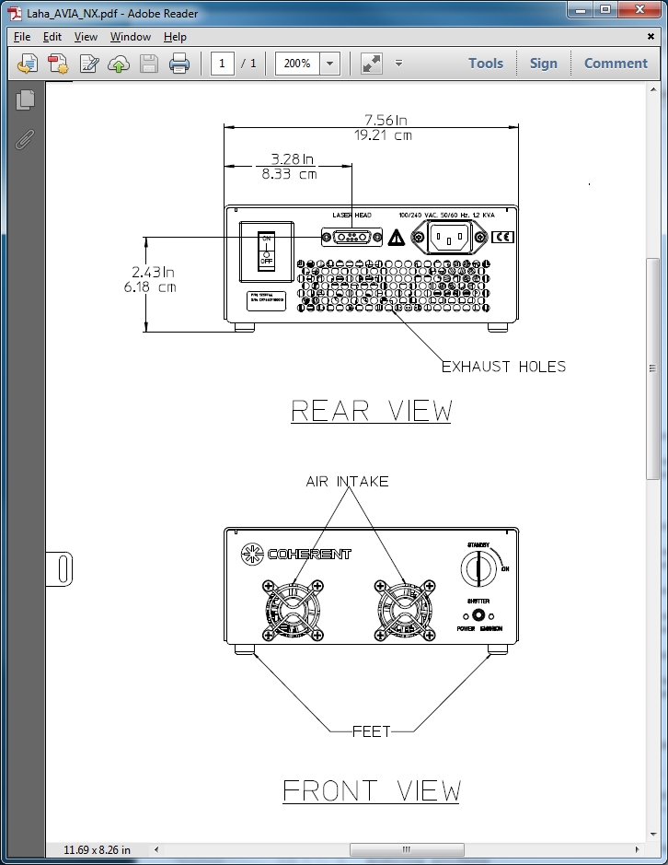

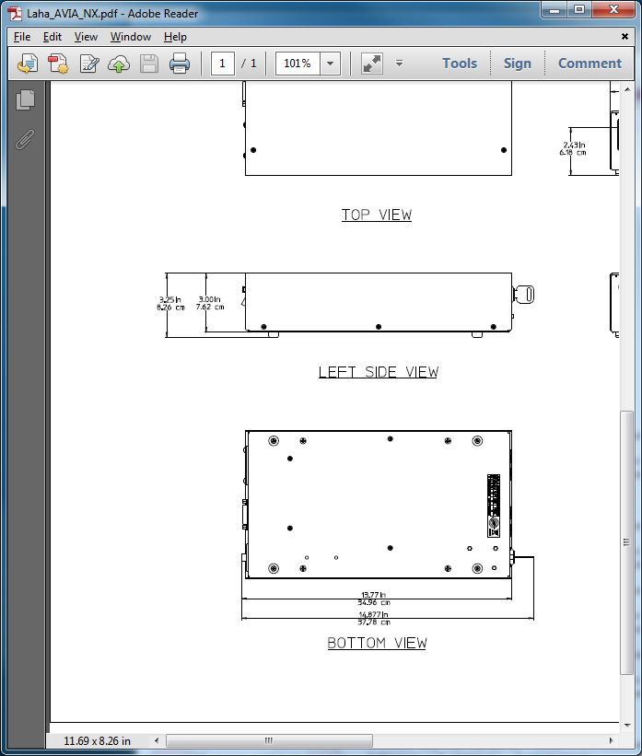

## Lambda converter

In order to provide sufficient power and noise tolerance, the following Lambda converter has been qualified for use with MONACO. It is highly recommeneded that customers who choose to implement their own power supply use the identical AC/DC converter part number **RFE1000-48-Y** from Lambda with the following specifications. MONACO laser performance cannot be guaranteed if another converter is used. See the Lambda website at <http://us.tdk-lambda.com/> for further information.

48V 1000W AC-DC Converter:

* Nominal output voltage 48V (+/- 10% acceptable)
* Output current 21A
* Output power 1008W
* Line regulation 192mV
* Load regulation 384mV
* Output noise 300mV
* Overvoltage protection 62 to 66V
* Overcurrent protection 105-125% (non-foldback type)
* Over Temperature protection Yes, automatic reset
* AC Input Range 85-265VAC, 47-63Hz
* AC Input Current 12A @ 100VAC, 6A @ 200VAC
* Leakage current <1.1mA at 230VAC
* Inrush current <40A
* Hold up time (100VAC input) 20ms typical
* Immunity EN61000-4-2, -3, -4, -5, -6, -11
* EMC (conducted & radiated) EN55022, level B, FCC part 15J-B
* Operating temperature 0 to +70C
* Storage temperature -30 to +85C
* Withstand Voltage Input to Output 3kVAC, Input to Ground 2kVAC, Output to Ground 500VAC for 1 min.
* Isolation Resistance >100M at 25°C & 70%RH, Output to Ground 500VDC
* Shock & Vibration Meets ETS 300 019
* Safety Agency UL60950-1, EN60950-1 (Ed 2), CE Mark

In summary, this converter requires the following input:

* 100-240VAC
* 50/60Hz
* 1.2 KVA

## Power conditioning

At the AC power entry to the Lambda converter, the following components are recommended. Part numbers are provided for reference.

* EMI Filter Radius Power RP185-15-4.7-QD
* 15A circuit breaker Airpax R21-2-15.0A-B06CV-V

# BASIC COMMANDS FOR OPERATION

Below is a subset of MONACO commands. They are supplied here as a guide to get started quickly using MONACO.

Please note the **?HELP** command supplies a list of all possible commands. It is also possible to enter **?HELP <keyword>** for a list of all possible commands with <keyword> in it. The ?HELP command can show other commands that are not listed below.

For initial setup of the laser, we encourage use of the Coherent GUI which defers any need for these commands.

|  |  |  |
| --- | --- | --- |
| **Command** | **Brief description** | **Notes** |
| BP | Burst Pulses | Number of pulses in a burst |
| ?BP | print Burst Pulses | Returns number of pulses in a burst |
| CHEN | CHILLER ENABLE | Send ‘CHEN=1’ to turn on the chiller. |
| ?F | PRINT FAULTS | Displays a list of faults, if present. Use the ?FNAME command to show a description of a particular fault. If a fault is present, it will turn off the laser. |
| FACK | ACKNOWLEDGE FAULTS | Send ‘FACK=1’ to acknowledge faults and return the laser to a ready state if the fault condition is lifted.. |
| ?FNAME | PRINT FAULT NAME | For example send ‘?FNAME 4’ to get the description for fault 4. |
| ?HELP | PRINT HELP | Shows list of all commands or a subset if a keyword is used. For example ‘?HELP SHG’ shows all SHG related commands. |
| ?HV | PRINT HARDWARE VERSION | Displays the internal revision level of major hardware components. |
| ?K | PRINT KEYSWITCH | Returns laser enable key switch state  1 = Laser Enabled  0 = Laser in Standby (laser diodes cannot be turned on) |
| L | LASER ENABLE | L=1 turns on laser.  L=0 turns off laser. |
| ?L | PRINT LASER STATE | Send ‘?L’ to get a number of what state the laser is in. Then use ‘?LNAME’ to convert the state number into a description. See also the ?ST command. |
| ?LNAME | PRINT STATE DESCRIPTION | For example send ‘?LNAME 1’ to get the description of state 1. |
| ?LM | PRINT LASER MODEL INFO |  |
| PC | PULSE CONTROL | Enable or disable laser pulsing  PC=1 enables laser pulsing  PC=0 disable laser pulsing |
| ?PC | PRINT PULSE CONTROL | Returns the state of laser pulse control  1 = laser pulsing on  0 = laser pulsing off |
| PM | PULSE MODE | PM=0 for continuous pulsing  PM=1 for gated mode  PM=2 for Divided mode  PM=3 for Divided and Gated  PM=4 for Burst  PM=5 for Burst and Divided |
| ?PM | PRINT PULSE MODE | Returns the pulse mode |
| RL | SET PULSE LEVEL | Sets the pulse level |
| ?RL | PRINT PULSE LEVEL | Returns the current pulse level setting. |
| ?RR | PRINT REP RATE | Returns laser pulse repetition rate in Hz |
| RRD | SET REP RATE DIVISOR | Allows the laser pulse repetition rate to be divided by an integer. |
| ?RRD | PRINT REP RATE DIVISOR | Returns the laser pulse repetition rate divisor. |
| S | SHUTTER | Open or close shutter  S=1 opens the shutter;  S=0 closes the shutter. |
| ?S | PRINT SHUTTER | Returns the state of the shutter  1 = shutter is open;  0 = shutter is closed. |
| SET | SET OPERATING RATES | The SET command allows you to set the rep rate, number of microburst pulses in a burst, and the pulse width based on the following:   * If the command is of the form SET=x then x is the requested rep rate in kHz with 1 pulse per burst. For example SET=1000 sets the rep rate to 1MHz (1000 kHz). Note that the repetition rate must be a value that has an integer divisor from 1 MHz (eg. 500kHz, 333kHz, 250kHz, etc) * If the command is of the form SET=x:y where y<100, then x is the requested rep rate in kHz and y is the number of microburst pulses per burst. For example SET=500:2 gives a 500kHz rep rate with 2 microburst pulses. * If the command is of the form SET=x:y where y>=100, then x is the requested rep rate and y is the pulse width in fsec. * If the command is of the form SET=x:y:z and y<100, then x is the requested rep rate in kHz and y is the number of microburst pulses per burst and z is the pulse width in fsec. For example SET=500:2:600 gives a 500kHz rep rate with 2 microburst pulses at 600fsec. |
| ?SET | PRINTS THE OPERATING RATES | Returns the current internal repetition rate. |
| SSP | SESAM SPOT | For example use ‘SSP=+’ to shift to the next available spot. |
| ?SSP | PRINT SESAM SPOT | Returns current SESAM spot position |
| ?SSPH | PRINT SESAM SPOT HOURS | Returns current SESAM spot hours |
| ?ST | PRINT LASER STATE NAME | Returns the name of the current laser state such as ‘Standby’, ‘Ready’, ‘Fault’ or ‘On’ when the laser reaches those steady state conditions. It can also return transient laser states, such as diode current ramping up or down. The ?L command is a short form of this command. |
| ?SV | PRINT SOFTWARE VERSION | Displays the internal revision level of major software components. |
| ?IRE | PRINT IR ENERGY | Returns laser pulse energy in uJ |
| ?IRP | PRINT IR POWER | Returns laser average power in W |
| ?W | PRINT WARNINGS | Displays a list of warnings, if present. Then use the ?WNAME command to show a description of a particular warning. Warnings will not turn off the laser. |
| ?WNAME | PRINT WARNING NAME | For example send ‘?WNAME 100’ to get the description for warning 100. |
|  |  |  |

## Interlock Faults and warnings

The following table shows faults and warnings that can occur because of interlock failures. When a fault occurs, the laser is shut down and put into a standby state. Warnings will not shut down the laser. The faults and warnings can be listed with the ?F and ?W commands. These commands reply with a list of fault or warning numbers. After any fault occurs, it must be acknowledged with the FACK=1 command and the failing condition cleared before the laser will resume normal operation. The description for any fault or warning number can be seen with the ?FNAME and ?WNAME commands.

|  |  |
| --- | --- |
| **Fault number** | **Description** |
| 1 | Emission Lamp Interlock Fault |
| 2 | External Interlock Fault |
|  |  |
| **Warning number** | **Description** |
| 105 | Shutter Interlock Warning |
|  |  |

## Example command sequence

The following is an example of commands that can be used to control the laser. This is only an example and not intended for use without fully understanding if the commands are appropriate for the process the laser is being used for. **Changes may be required. It is the customer’s responsibility to comply with IEC60825 safety standards when using these commands.**

### Startup – Regular operation

|  |  |  |
| --- | --- | --- |
| **Command** | **Expected reply** | **Notes** |
| CHEN=1 |  | Enable the chiller. For the most stable laser operation, the chiller should be enabled several minutes before turning on the laser. |
| ?K | 1 | Checks keyswitch is on |
| ?F | SYSTEM OK | Checks that there are no faults. |
| ?W | SYSTEM OK | Checks that there are no warnings. |
| S=0 |  | Closes shutter |
| ?S | 0 | Checks that shutter is closed |
| PM=0 |  | Setup continuous pulsing |
| ?PM | 0 | Checks that continuous pulsing is setup |
| L=1 |  | Turn on diodes. They will typically ramp to their set current within (TBD) seconds. |
| ?ST | On | This query may be repeated once a second until “On” is returned, which indicates the diodes have completed ramping to their set point. This query may also return the description of other intermediate states. Note that if the laser is cold from a power off state, it may take several minutes to become thermally stable and reach a steady state. |
| PC=1 |  | Turn on pulses |
| S=1 |  | Open the shutter |
| ?S | 1 | Check that the shutter is open |

### Monitoring while operating

These commands can be issued periodically every few seconds or minutes while the laser is operating.

|  |  |  |
| --- | --- | --- |
| **Command** | **Expected reply** | **Notes** |
| ?F | SYSTEM OK | This command replies with a list of numbers if a fault exists. The *?FNAME n* command can be used to describe the fault condition n if it exists. The laser will automatically go to a standby state when there is a fault condition. Faults are cleared with the FACK=1 command if the fault condition is lifted. |
| ?W | SYSTEM OK | Same as ?F except for warnings. Warnings do not change the state of the laser. It continues to operate. |

### After process is complete – Check hours and spot condition

|  |  |  |
| --- | --- | --- |
| **Command** | **Expected reply** | **Notes** |
| S=0 |  | Close shutter |
| ?S | 0 | Check that the shutter is closed |
| PC=0 |  | Turn off pulses |
| ?PC | 0 | Check that pulsing is off |
| ?HH | n.n | A number of total head hours will be returned as a floating point value. |
| ?SSPH | n.n | The number of operation hours on the currently active spot will be returned as a floating point value. |
| If SESAM spot hours have exceeded some threshold such as 500 hours, a decision can be made to move to the next available spot. Other factors such as available power may also influence this decision. A warning message can be set up to indicate crystal spot change may be needed to maintain ideal laser output. | | |
| SSP=+ |  | This moves the SESAM to the next available spot. |
| ?SSP | n | Returns an integer indicating the current spot number. |

### Shutdown

|  |  |  |
| --- | --- | --- |
| **Command** | **Expected reply** | **Notes** |
| S=0 |  | Close the shutter and turn off AOM2 |
| ?S |  | Check that the shutter is closed |
| L=0 |  | Turn off diodes |
| ?ST | Ready | Repeat this command every few seconds while diodes are turning off and wait for the ‘Ready’ reply. This command will also return the description of other intermediate states. |

# Document change log

|  |  |  |  |
| --- | --- | --- | --- |
| Version | Author | Date | Changes |
| 0.01 | FJC | 5/14/2014 | Initial draft |
| 0.02 | FJC | 5/19/2014 | Adjusted connections and commands based on feedback from Xuren. |
| 0.03 | GD | 5/29/2014 | Many edits, mostly in schematic sections |
| 0.04 | FJC | 6/12/2014 | Added chiller enable and fixed extended interface pinout to match Staccato. |
| 0.05 | FJC | 7/15/2014 | Added table for various beam modulation modes |
| 0.06 | FJC | 2/6/2015 | Updated chiller & interlock & extended interface connectors to match rev AC headboard. Also updated photo at back of laser showing connectors. |
| 0.07 | FJC | 3/17/2015 | Changed Sync1 & Sync 2 impedance to 50 ohm to match rev AC headboard. |
| 0.08 | FJC | 4/13/2015 | Corrected wording for Extended interface pins 12, 17 and 19 which are pulled down not up. |
| 0.09 | GD | 8/26/2015 | Added detail to Sync 1 and Sync 2 descriptions |
| 0.10 | FJC | 10/6/2015 | Corrected typo in diagram showing position of connectors. RS232 and Chiller were reversed. |
| 0.11 | FJC | 10/6/2015 | Extended Interface pin 22 is also no connect. |
| 0.12 | FJC | 11/19/2015 | Clarified description of extended interface pin 19. |
| 0.13 | FJC | 1/19/2016 | Adjusted sync signal width which is 50ns (not 40ns) and added SET command with examples. |
|  |  |  |  |
|  |  |  |  |
|  |  |  |  |